**Computational Photography and Image Manipulation**

**Programming Assignment 2**

**Report**

First of all, I had problems understanding the sparse matrix, which led to incorrect calculation of the variables adjacent to A in the algorithm, and also only the height and width of these images were calculated, and the color channel was not managed. This resulted in setting up the discrete Laplace operator A and iterating over the b variables and outputting a grayscale image of these masks on target.

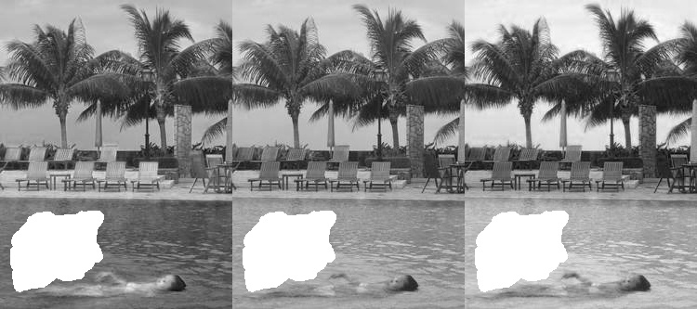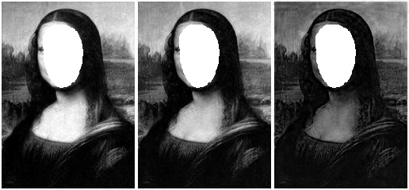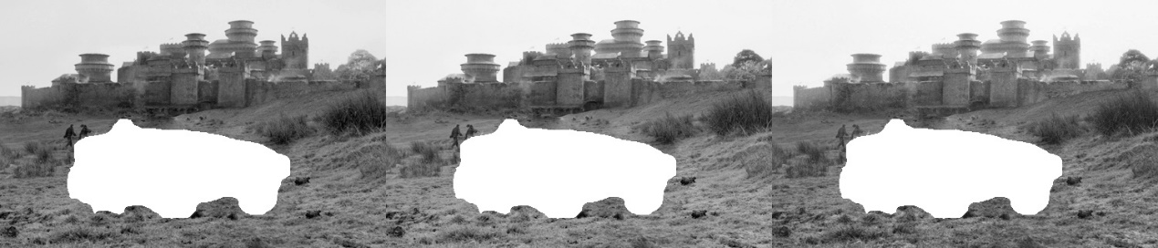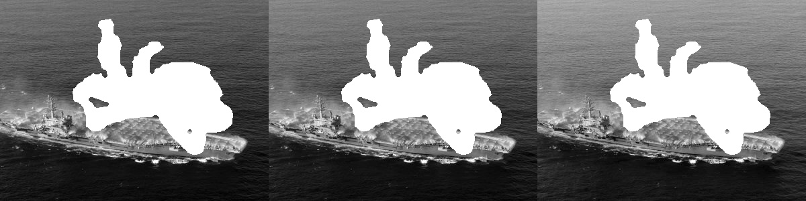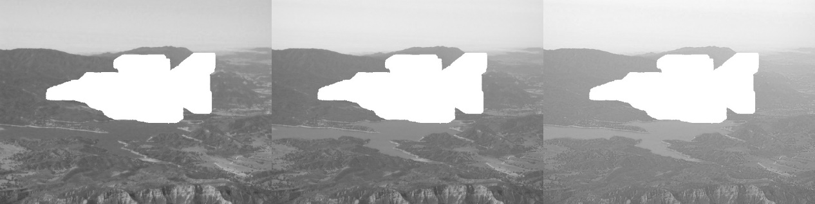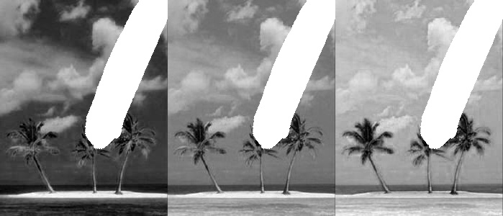

The second time I added the third dimension of the color channel and then changed the top and bottom neighbors adjacent to operator A and then applied the given gradient equation. However, since I did not put operator A and variable b into the color channel for iteration, the output image color did not correspond. It is shown below:

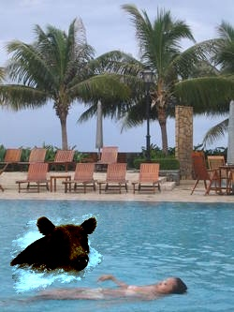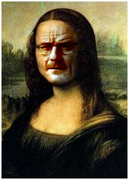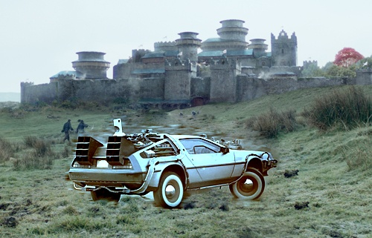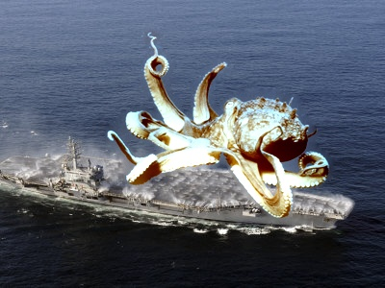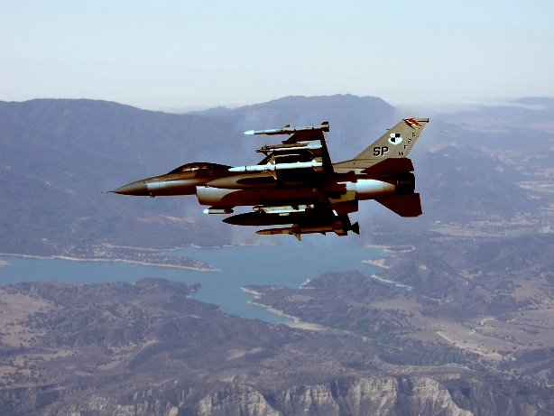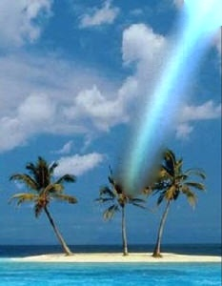

In the end I put all the steps together in their entirety and came up with the correct result:

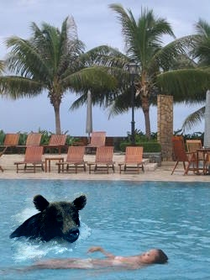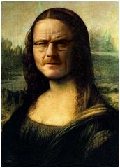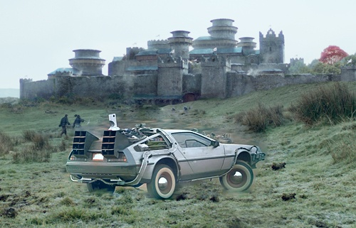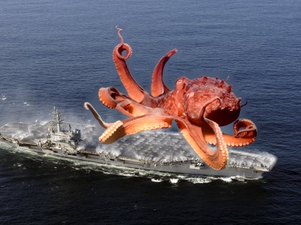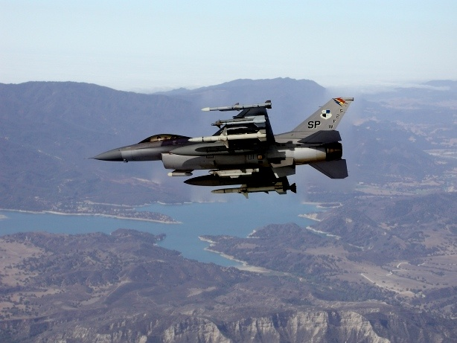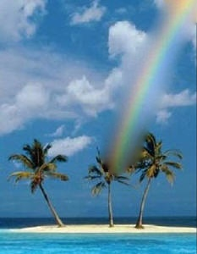

In the image I took myself, it doesn't run out of results, reporting an error that the offset setting is over the limit. In fact, I tried all combinations and none of them worked, but I think the reason for this is that I didn't handle the mask, source, and target images correctly, which resulted in the size exceeding the limit. Anyway, I put the mask, source and target images into a data folder named 7 through 9 .